Supercapacitors are a type of capacitor that has gained appeal as the world has done its best to move away from harmful chemical energy sources to renewable ones. The “super” in supercapacitor comes not from its ability to store energy, but from their ability to deliver power that is unmatched by its counterpart, the Li-Ion battery. The technology that supercapacitors (SC’s) rely on is the electric double-layer (EDL). Helmholtz, Guoy-Chapman, Stern and Graham models are the most highly researched in regard to these EDL’s[1]. Instead of conventional dielectrics, these EDL’s rely on a liquid electrolyte dielectric. The electrodes used are also unconventional. The two most important features that are used to measure a SC’s usefulness is its specific power density (SPD) and specific energy density (SED). These are the characteristics that researchers work most to alter. The many ways in which they attempt to do so, and their success will be expounded on further in the body of this paper.

To understand the motives behind the direction of the research concerning SC’s, it is necessary to gain a better understanding of the electric double-layer. The electric double layer is the theoretical foundation that gives a supercapacitor its unmatched qualities. Helmholtz was the first to lay down the framework for electric double layers. His idea was that at the boundary between an electrode and an ionic liquid dielectric, a high potential could be created. As indicated in figure 1, the charges that build up on the electrode like in a conventional capacitor attract oppositely charged ions in the dielectric.

Helmholtz built his theory on the assumption that there is a rigid layer formed at the boundary of the electrode and dielectric. This does not occur in nature, and it wasn’t until Guoy and Chapman both independently put forth their theories that the EDL was better understood. The Guoy-Chapman model proposed that the potential doesn’t just depend on the ions at the boundary but also the ions in the “diffuse” layer. The counter ions (the ions countering the charge on the electrode) will diffuse into the liquid layer in the dielectric. The more ions that have diffused the harder it is for the counter ions to continue to diffuse, due to the counter-potential that is created in the diffuse layer. It was theorized that the change in concentration of these ions follows the Boltzmann distribution *n = $n0*exp(-ZeѰ/kT)$* . Where n0 is the bulk concentration, Z the charge of the ion and e the charge of the proton[2]. This theory is already in error because it assumes that the amount of dispersion is equal to the concentration of the ions in the dielectric. This is a good approximation, but this is not true at the charged surface layer between the dielectric and electrode. Guoy-Chapman concerned themselves with the volume charge density, in general i  = zieni.. The potential can be found using this relation Poisson’s equation d2/dx2 = -4/d. The boundary conditions for this potential are that the potential is o at the surface of boundary and zero at the end of the bulk solution. Finally the potential at a distance from the surface is given by double = [rkT/(4e2niozi2)]1/2 and simplified at room temperature to be double = 3.3*106r/(zc1/2).

As it turns out, the Guoy-Chapman model does not accurately describe the double-layer potential, it only offers a very good approximation. It was Stern who finally completed the theory when he integrated the ideas that the ions did indeed have a finite size, and that their approach to the surface between electrode and dielectric was inhibited by this. Thus there is a spacing taken to be the radius of the ion that separates the ions from the surface. This spacing is what is called the Stern Layer. The potential changes linearly across this Stern Layer and then exponentially decreases once in the diffuse layer as indicated in figure 1.

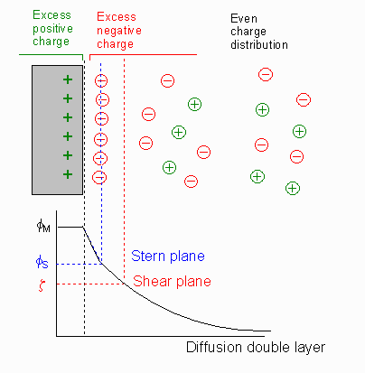**Fig 1. The voltage through the Stern Layer drops off linearly. Once the diffuse**

**Layer is reached the voltage drops off exponentially.2**

Now with a better understanding of the EDL it is clear that the synergy between the electrode and dielectric is very important when attempting to change the properties of a SC, namely the SPD and SED. Below, figure 2 is an attempt at displaying the way in which one of the main characteristics of a dielectric—the porousness— affects the way in which the ions interact with the dielectric.

Often the most widely varied component of a supercapacitor is its electrodes. The most common types of electrodes are made from carbonaceous materials that are then activated in one of four ways. Carbonaceous materials, like biomass, are used for their especially porous structure. This porous structure leads to a high surface area within the material. The higher the surface area the higher the specific capacitance and power per weight of the electrode[3]. These specific power densities can range anywhere from 5-15 kW/kg2. As stated previously, these SC’s have low specific energy densities compared to Li-ion batteries and for that reason SC cells are engineered in combinations of circuit designs. The most commercially and traditionally produced SC have been tested against a variables such as temperature. The variance of the capacitance in a range of common but extreme temperature was only 1-3%2. This is a great feature for the integration of these SC into everyday applications.

Physical (thermal), chemical, physiochemical, and microwave-induced are the four most common processes for creating activated carbon (AC) from base carbonaceous materials. The process of physical activation consists of first heating the carbonaceous substance to a range between 400-850 deg C[4]. Once the sample is heated and the surface has blackened, the carbon is activated with oxidizing gases like air, steam, or carbon dioxide that are heated between 600-900 deg C. The major function of this activating gas is to increase the porousness or the overall surface area of the original material.

Chemical activation most commonly utilizes potassium hydroxide and zinc hydroxide to pre-treat the carbonaceous material before activation occurs. Once the precursor material is treated, it is activated by heating to a range of 350-900 deg C3. This heating process is again to make the structure as porous as possible. This process is more environmentally dangerous, time consuming, and expensive claims the author. This is because of the process of washing the AC of the initial activation chemicals. The final porousness has a high variability with chemical ratio and temperature.

Microwave assisted activation was proposed as a way to get around the issues posed by conventional heating. The temperature gradient caused by conventional heating leads to a porously inhomogeneous structure. Microwave heating transfers energy to the carbon by the oscillations of dipole rotations3. This method offers low energy costs and fast activation times. These advantages have caused this method to become a popular method for carbon activation.

An emerging area of electrode research is that of a graphene and graphene-hybrid electrodes. A major drawback to common AC electrodes is their low electrical conductivity. Electrochemically exfoliated graphene (EEG) and EEG/AC hybrids have a much higher electrical conductivity of 2.68E4 S/m as was found in research by Tsaia[5]. Other alternatives to AC such as carbon nanotubes also work around this issue, however their structure severely decreases the specific capacitance of SC’s. Graphene seems to work around all of these issues do its high capacitance, porous structure, and high thermal and chemical stability. Pure EEG electrodes when coupled with a potassium hydroxide dielectric reached 65 kW/kg, over a four-fold increase from the best traditional AC electrodes4. The creation of these electrodes is not difficult. Mixing different weight ratios of AC and EEG powder in super-pure water for 24-hours is all that the process consists of. Tsaia first created these EEG and EEG/AC electrodes as small pouches, and then scaled them up to commercial production size. After the scaled versions were put through 10,000 cycles, their capacitance was retained to within 95% the original proving this is a viable option for industry.

Many different components are taken into consideration when attempting to build the most useful supercapacitors. Electrodes, dielectrics, and the circuits in which these SC’s are integrated into are all areas of intense research. These researches are proactively finding the answers that will soon be necessary to the world’s infrastructure.

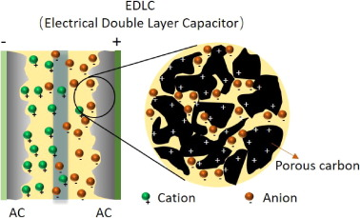

**Figure 2 – At the surface of the dielectric-electrode layer[6].**

Different types of electrodes do a lot to change the properties of SC’s, especially their SPD, which is what makes SC’s so useful in the first place. The SED of a SC, however, is currently the one major drawback. A promising approach to fixing this issue has been found in research considering the dielectric used in SC’s. Different types of electrolytic solutions are used in order to make these dielectrics. Regular ionic solutions (potassium hydroxide, sodium hydroxide etc.) are commonly used in SC, however researchers are branching out to different types of dielectrics. Ionic liquids have been a part of this research. Ionic liquids are chemical salts in the liquid phase. The theoretical motivation for testing IL’s is that the ions in the liquid are better at accumulating at the EDL, meaning they do not diffuse back into the neutral part of the dielectric where the potential changes more slowly. This feature allows for a higher specific energy density in SC, a marked disadvantage of SC’s in general. The cost of these IL’s have abruptly decreased due to an increased supply driven by commercial demand, but still the cost remains an issue for SC developers interested in using IL’s. IL’s are also very susceptible to contamination, and purity is crucial to successful IL implementation. The complexity of the molecules chosen to make the IL’s adds a notable level of difficulty to engineering a SC. A list of different types of SC IL combinations and their respective SED and SPD are given in the table below. 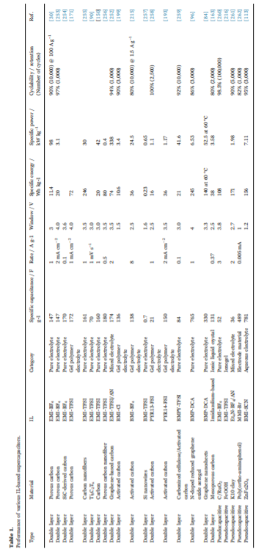

**Figure 3- Table of SED and SPD for different dielectrics.[7]**

The molecules are very complex compared to normal ionic solutions. This complexity pays off however. The graphs in figure 4 compare the SED and SPD of SC’s made with an IL, the commonly used electrolyte KOH, and Lithium hexafluorophosphate electrolyte. All of these dielectrics were coupled to a graphene electrode. The first graph shows the differences in what is called the potential window of a capacitor. The potential window is just the range of potential in which the capacitor can stably operate. From the graph it is seen that the potential window of the IL chosen is over 3x the length of the common KOH dielectric. This is how the energy density of SC is significantly increased by the use of IL dielectrics: the energy stored in capacitors is proportional to the square of the operating potential. IL electrodes are trickier to deal with and more expensive but the payoff is an order of magnitude increase in the energy density. The reason the IL is more stable is because it is made up of individual ions that don’t participate in any reactions over a wider range of potentials. This is also why it is so important that the dielectric be ultra-pure. When coupled to common carbon electrodes, IL’s actually tend to react with the irregularities in the electrode at the boundary. This severely decreases the potential window of the SC. It is reported that some graphene-IL SC’s have reached a potential window of 10V.

Energy density is one of the major drawbacks of SC’s. It is very interesting that graphene electrodes not only significantly increase the SPD of SC’s, but when coupled with IL dielectrics also make astounding progress in increasing the SED of the SC—historically a major drawback of SC compared to Li-ion batteries. The graphene-IL SC seems like the best combination that is being researched right now by far. Right now IL’s are much more expensive than their counterparts. As more research is done and the need for SC increases, hopefully the cost will continue to fall.

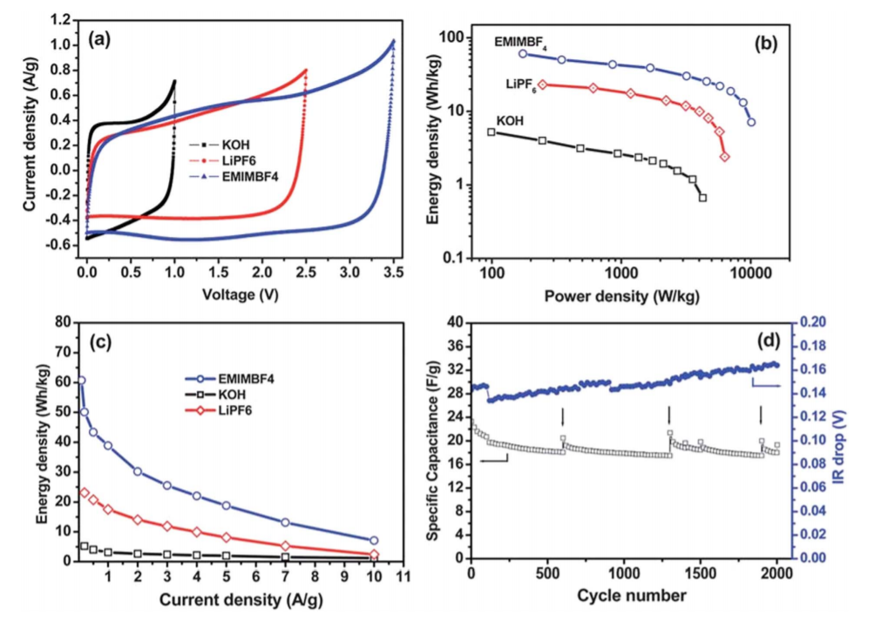

**Figure 4- Comparing the SED of different dielectrics with graphene electrodes.7**

Supercapacitors are already implemented into everyday life through the use of electric cars and home battery cells, but there is still a lot of potential (no pun intended) left untapped in these devices. Through the implementation of new materials like graphene, this potential is already being unlocked further. Ingenuity and new developments in field like material science are going to be what propels SC capabilities further. Attitudes towards how mankind is going to continue to produce energy are shifting more and more towards renewable energy, and supercapacitors will be crucial in not only being able to store energy and make it transportable but also to be able to use it quickly enough for the machines necessary for our infrastructure. No other type of battery device can deliver the type of power that supercapacitors can, and their ability is only getting greater. The unmatched cycling efficiency of SC’s is also what makes them so appealing, and the resources saved by not having to replace Li-ion batteries all the time is a huge advantage. If the specific energy density of SC’s can get to the level of Li-ion batteries, or even surpass them, which is definitely possible as the research has shown with Ionic liquid dielectrics then Li-ion batteries can become obsolete. The main challenge to achieving this is that it is still very expensive to implement these technologies and purchase the materials necessary to achieve these properties. It is highly probable that as the demand for renewable energy increases a producer will acquire the economy of scale necessary to produce the components of high-grade SC’s at a reasonable price. At this point SC’s seem to be the leading technology amongst the energy storing devices available to the world. One day they may be what is propelling the world forward.

1. https://ac.els-cdn.com/S0169433217336760/1-s2.0-S0169433217336760-main.pdf?_tid=24e5145a-0b5b-11e8-ba55-00000aacb35e&acdnat=1517934852_45e8c232543e99de5a0e627eb2408ed1
2. https://web.nmsu.edu/~snsm/classes/chem435/Lab14/double_layer.html
3. Devillers, Jemei, Pera, Bienaime, Gustin
4. Abioye, Nasir Ani
5. Tsaia, Caob, Fevrea, Wangc, Todda, Dryfec, Forsytha
6. # Materials for supercapacitors: When Li-ion battery power is not enough

   Author links open overlay panel[Z.Lin](https://www.sciencedirect.com/science/article/pii/S1369702117307988" \l "!)[12](https://www.sciencedirect.com/science/article/pii/S1369702117307988" \l "!)[E.Goikolea](https://www.sciencedirect.com/science/article/pii/S1369702117307988" \l "!)[34](https://www.sciencedirect.com/science/article/pii/S1369702117307988" \l "!)[A.Balducci](https://www.sciencedirect.com/science/article/pii/S1369702117307988" \l "!)[56](https://www.sciencedirect.com/science/article/pii/S1369702117307988" \l "!)[K.Naoi](https://www.sciencedirect.com/science/article/pii/S1369702117307988" \l "!)[78](https://www.sciencedirect.com/science/article/pii/S1369702117307988" \l "!)[P.L.Taberna](https://www.sciencedirect.com/science/article/pii/S1369702117307988" \l "!)[12](https://www.sciencedirect.com/science/article/pii/S1369702117307988" \l "!)[M.Salanne](https://www.sciencedirect.com/science/article/pii/S1369702117307988" \l "!)[29](https://www.sciencedirect.com/science/article/pii/S1369702117307988" \l "!)[G.Yushin](https://www.sciencedirect.com/science/article/pii/S1369702117307988" \l "!)[10](https://www.sciencedirect.com/science/article/pii/S1369702117307988" \l "!)[P.Simon](https://www.sciencedirect.com/science/article/pii/S1369702117307988" \l "!)[12](https://www.sciencedirect.com/science/article/pii/S1369702117307988" \l "!)
7. **Supercapacitors Utilizing ionic liquids Ali Eftekharia,b**